

Scripps College of Communication

E.W. Scripps School of Journalism Schoonover Center 200
1 Ohio University
Athens, OH 45701-2979

T: 740-593-2590
F: 740-593-2592
Scrippsjschool.org

April 18, 2024

To Whom it May Concern:

I am writing this letter on behalf of Mara Bradley, a journalism student of the class of 2025, and a candidate for an internship with your organization.

I have known Mara as a student in my Mass Media Writing Principles class during the spring of 2024.

While this online class does not allow me the opportunity to more fully observe these students’ behaviors, I can glean something about them from their submissions and the manner in which they perform in class beyond mere grades. Mara was the only student in the class to work in advance. She could have easily completed the entire course in a fraction of the time allotted had she been permitted to do so.
Her work was always excellent and her follow-up communication with me indicated a passion for understanding the material.

Looking through her resume, I see a person who is trusted with important duties and one who has been able to work her way through the ranks. I believe she would be a welcome addition to your group of interns. I ask that you favorable consider her for this honor.

Sincerely,

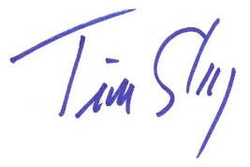
Tim Sharp
Assoc. Professor of Journalism Instruction, Emeritus
E.W. Scripps School of Journalism

